Give a database schema for a library management system as the following picture

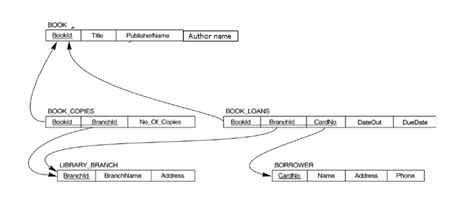

Create the required tables and perform the following queries on it.

a)List the details for all books whose title ends with ‘R’.

b) How many copies of the book titled “DBMS” are owned by the library branch whose name is “ABC”.

c) Retrieve the names of all borrowers who do not have any books checked out .

d) For each book whose DueDate is 11th October 2022, retrieve the book title, the borrower's name, and the borrower's address.

e) For each library branch, retrieve the branch name and the total number of books loaned out from that branch.

Consider the table Account(Customer name, account number, date_last transaction, amount).

f) Write a PL/SQL function that will retrieve the account details when account no is given as input.

g) Write a PL/SQL block to perform the following action on the table using cursor .

i)if the last transaction is not on the current month insert the records into the table inactive customer

ii)otherwise check the balance amount and display the interest amount

i)if the balance amount is less than 50000 interest rate is 5% of the amount

ii)if it is between 250000 and 5 Lakhs interest rate is 10%

iii)if the amount is greater than 5 lakh interest rate is 15%